Project Design Phase
Solution Architecture

Date | 30 September 2026
Team ID | SWTID-2026-2306
Project Name | AI StudyBuddy API – Deliver Intelligent, Personalized Study Assistance
Maximum Marks | 4 Marks

Solution Architecture:
Solution architecture is a complex process – with many sub-processes – that bridges the gap between business problems and technology solutions. Its goals are to:
- Find the best tech solution to solve existing business problems.
- Describe the structure, characteristics, behavior, and other aspects of the software to project stakeholders.
- Define features, development phases, and solution requirements.
- Provide specifications according to which the solution is defined, managed, and delivered.

Solution Architecture Diagram – AI StudyBuddy API:

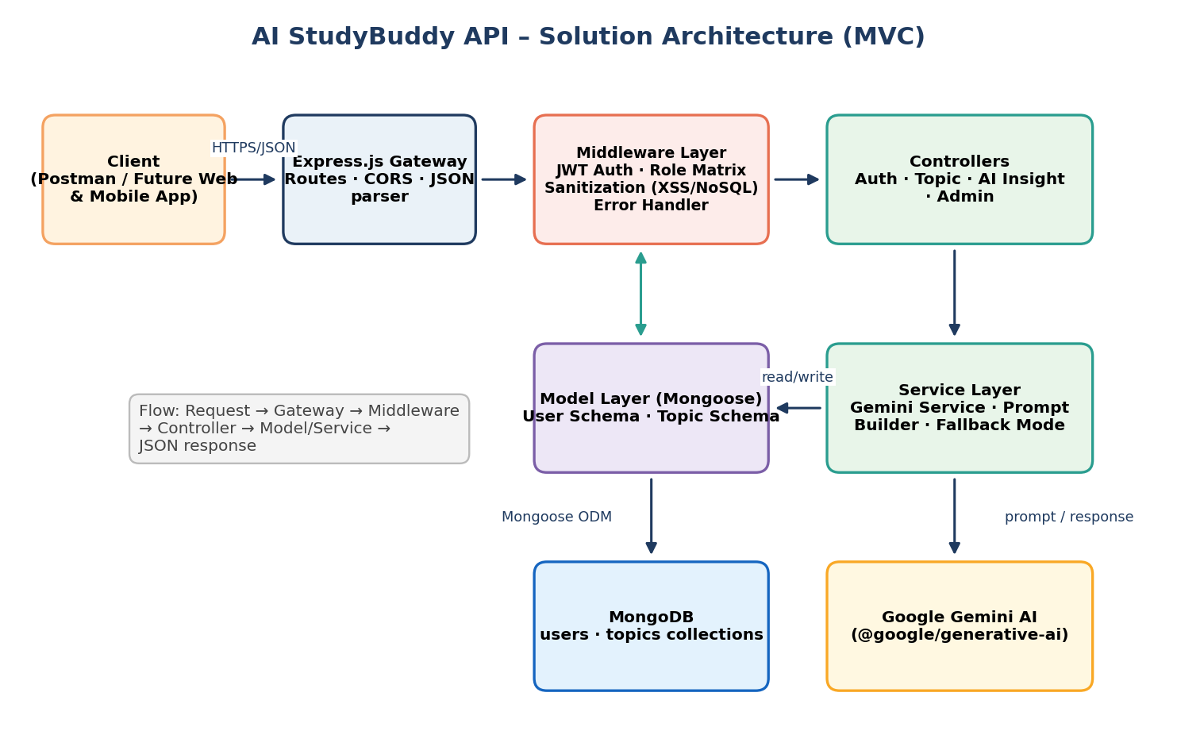
Figure 1: Architecture and data flow of the AI StudyBuddy API (MVC structure)
https://aws.amazon.com/blogs/industries/voice-applications-in-clinical-research-powered-by-ai-on-aws-part-1-architecture-and-design-considerations/Architecture Description:
- Client: Postman today; a web or mobile client can consume the same REST API in future.
- Express.js Gateway: receives HTTP requests, maps GET/POST/PUT/DELETE routes, parses JSON and handles CORS.
- Middleware: JWT authentication, role-matrix access control (student/admin), request sanitization against XSS and NoSQL injection, and a centralized error handler.
- Controllers: Auth, Topic, AI Insight and Admin controllers validate requests and coordinate business logic.
- Model layer: Mongoose User and Topic schemas (one-to-many) persisted in MongoDB.
- Service layer: Gemini AI service with prompt builder and fallback mode that returns a textual response if the AI key is missing or the call fails.

